**实验一 实验报告**

1. **全加器**

纸质表、卡诺图化简及逻辑表达式：

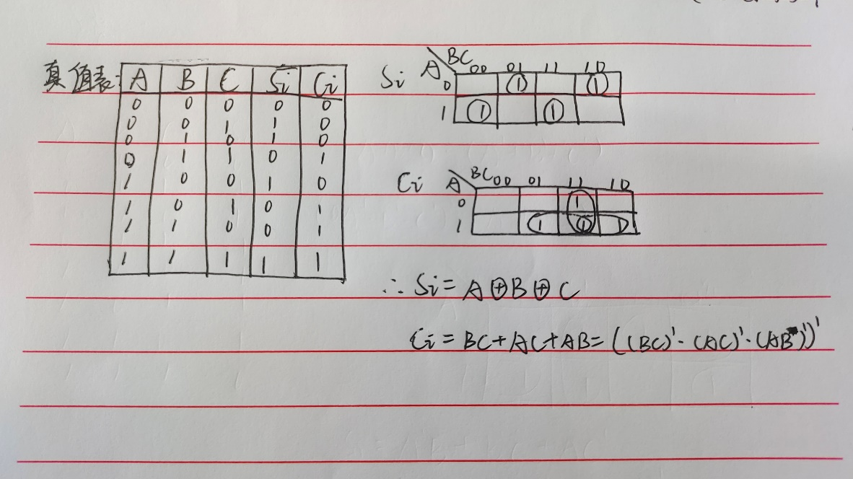

电路图：

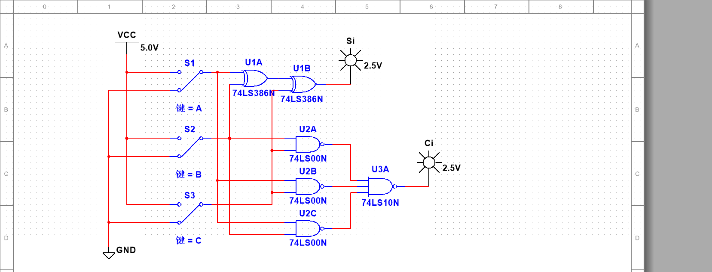

测试结果：

|  |  |  |  |  |
| --- | --- | --- | --- | --- |
| Ai | Bi | Ci-1 | Si | Ci |
| 0 | 0 | 0 | 0 | 0 |
| 0 | 0 | 1 | 1 | 0 |
| 0 | 1 | 0 | 1 | 0 |
| 0 | 1 | 1 | 0 | 1 |
| 1 | 0 | 0 | 1 | 0 |
| 1 | 0 | 1 | 0 | 1 |
| 1 | 1 | 0 | 0 | 1 |
| 1 | 1 | 1 | 1 | 1 |

1. **三变量不一致电路**

纸质表、卡诺图化简及逻辑表达式：

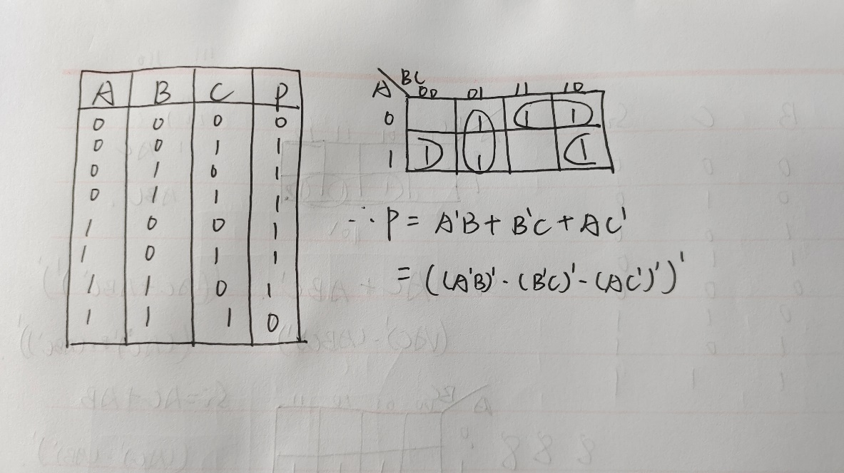

电路图：

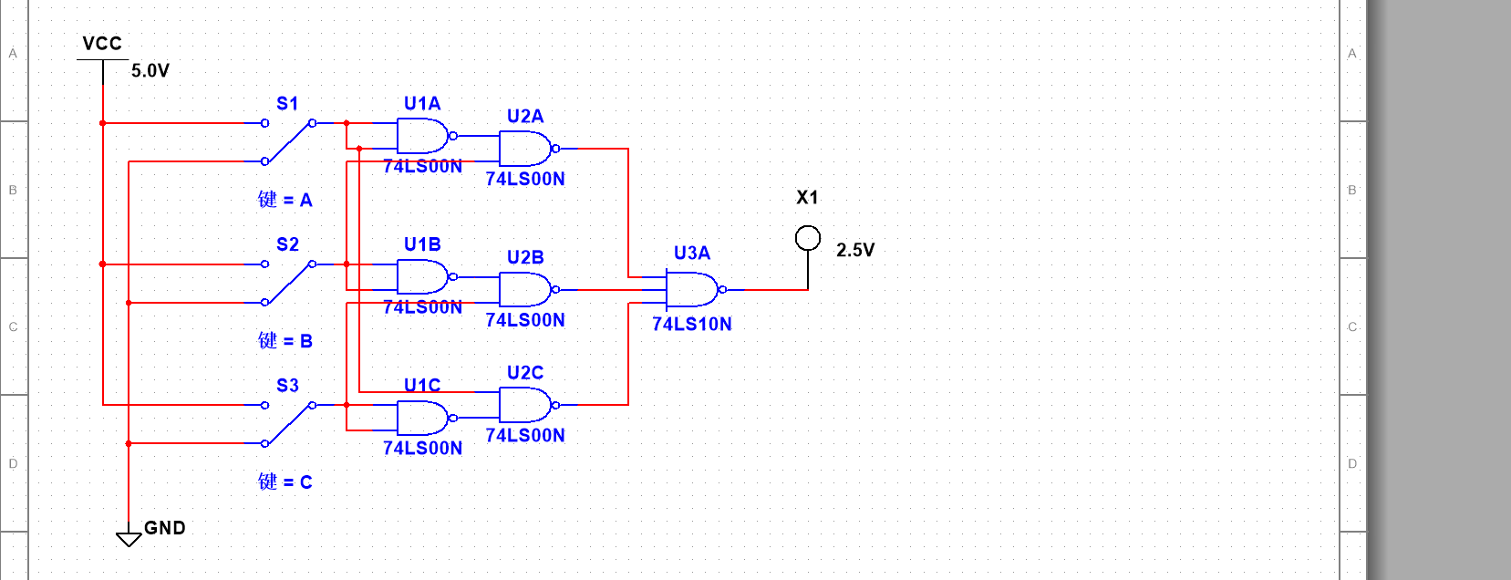

测试结果：

|  |  |  |  |
| --- | --- | --- | --- |
| Ai | Bi | Ci | P |
| 0 | 0 | 0 | 0 |
| 0 | 0 | 1 | 1 |
| 0 | 1 | 0 | 1 |
| 0 | 1 | 1 | 1 |
| 1 | 0 | 0 | 1 |
| 1 | 0 | 1 | 1 |
| 1 | 1 | 0 | 1 |
| 1 | 1 | 1 | 0 |

**（三）裁判表决电路**

纸质表、卡诺图化简及逻辑表达式:

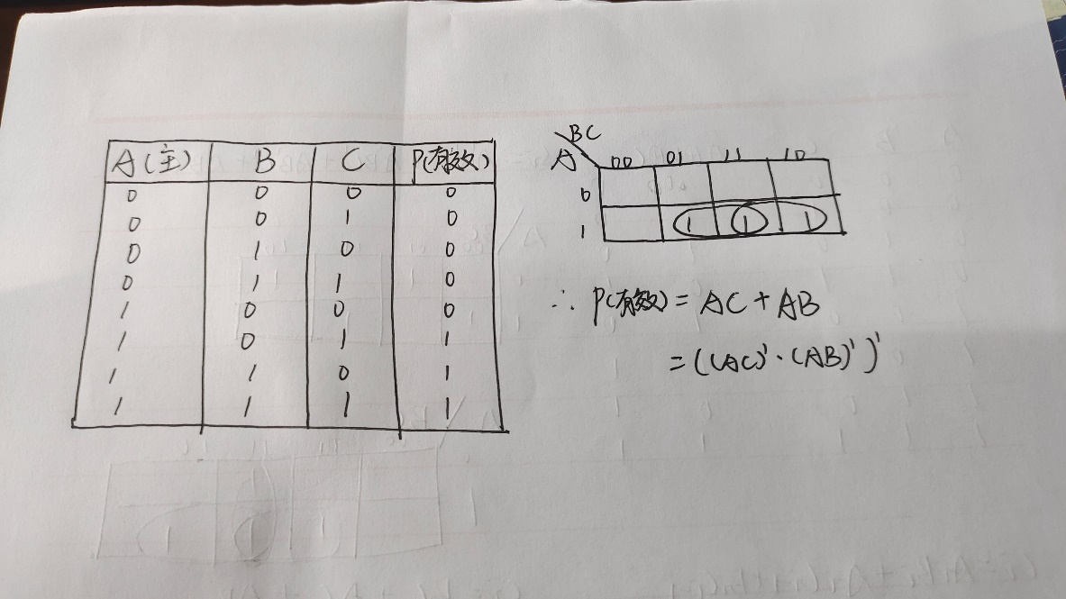

电路图：

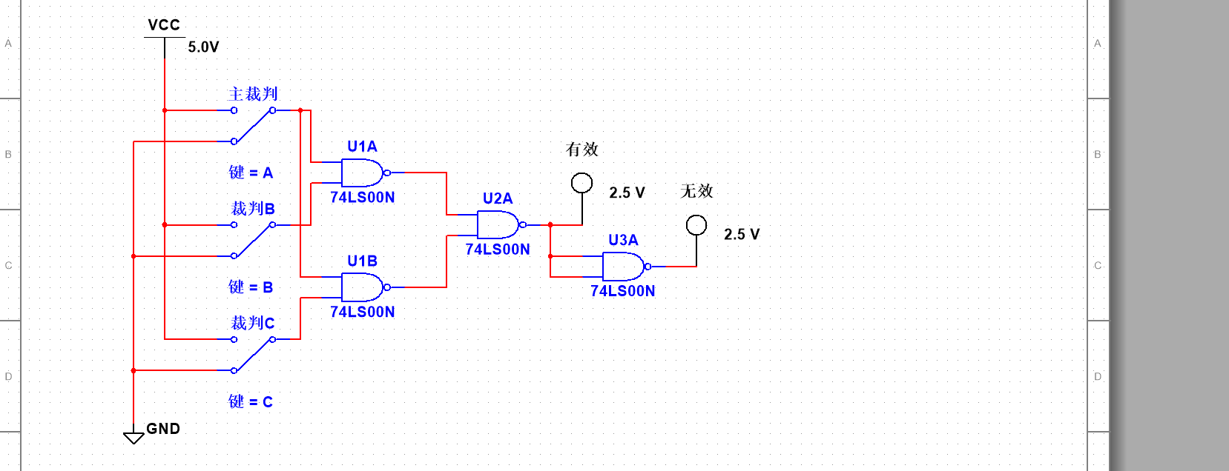

测试结果：

|  |  |  |  |  |
| --- | --- | --- | --- | --- |
| 裁判A(主) | 裁判B | 裁判C | P（有效） | Q（无效） |
| 0 | 0 | 0 | 0 | 1 |
| 0 | 0 | 1 | 0 | 1 |
| 0 | 1 | 0 | 0 | 1 |
| 0 | 1 | 1 | 0 | 1 |
| 1 | 0 | 0 | 0 | 1 |
| 1 | 0 | 1 | 1 | 0 |
| 1 | 1 | 0 | 1 | 0 |
| 1 | 1 | 1 | 1 | 0 |

**（四）简易自动售票机**

**实验二 实验报告**

**（一）8-3线优先编码器的测试**

|  |  |  |  |  |  |  |  |  |  |  |  |  |  |
| --- | --- | --- | --- | --- | --- | --- | --- | --- | --- | --- | --- | --- | --- |
| EI | I0 | I1 | I2 | I3 | I4 | I5 | I6 | I7 | Y2 | Y1 | Y0 | S | E0 |
| 1 | × | × | × | × | × | × | × | × | 1 | 1 | 1 | 1 | 1 |
| 0 | 1 | 1 | 1 | 1 | 1 | 1 | 1 | 1 |  |  |  |  |  |
| 0 | × | × | × | × | × | × | × | 0 |  |  |  |  |  |
| 0 | × | × | × | × | × | × | 0 | 1 |  |  |  |  |  |
| 0 | × | × | × | × | × | 0 | 1 | 1 |  |  |  |  |  |
| 0 | × | × | × | × | 0 | 1 | 1 | 1 |  |  |  |  |  |
| 0 | × | × | × | 0 | 1 | 1 | 1 | 1 |  |  |  |  |  |
| 0 | × | × | 0 | 1 | 1 | 1 | 1 | 1 |  |  |  |  |  |
| 0 | × | 0 | 1 | 1 | 1 | 1 | 1 | 1 |  |  |  |  |  |
| 0 | 0 | 1 | 1 | 1 | 1 | 1 | 1 | 1 |  |  |  |  |  |

**（二）3-8线译码器的测试**

|  |  |  |  |  |  |  |  |  |  |  |  |  |
| --- | --- | --- | --- | --- | --- | --- | --- | --- | --- | --- | --- | --- |
| 使 能 | | 选 择 | | | Y0 | Y1 | Y2 | Y3 | Y4 | Y5 | Y6 | Y7 |
| S1 | S2+S3 | A2 | A1 | A0 |
| × | 1 | × | × | × |  |  |  |  |  |  |  |  |
| 0 | × | × | × | × |  |  |  |  |  |  |  |  |
| 1 | 0 | 0 | 0 | 0 |  |  |  |  |  |  |  |  |
| 1 | 0 | 0 | 0 | 1 |  |  |  |  |  |  |  |  |
| 1 | 0 | 0 | 1 | 0 |  |  |  |  |  |  |  |  |
| 1 | 0 | 0 | 1 | 1 |  |  |  |  |  |  |  |  |
| 1 | 0 | 1 | 0 | 0 |  |  |  |  |  |  |  |  |
| 1 | 0 | 1 | 0 | 1 |  |  |  |  |  |  |  |  |
| 1 | 0 | 1 | 1 | 0 |  |  |  |  |  |  |  |  |
| l | 0 | 1 | 1 | 1 |  |  |  |  |  |  |  |  |

**（三）七段译码器的测试**

|  |  |  |  |  |  |  |  |  |  |  |
| --- | --- | --- | --- | --- | --- | --- | --- | --- | --- | --- |
| D | C | B | A | a | b | c | d | e | f | g |
| 0 | 0 | 0 | 0 |  |  |  |  |  |  |  |
| 0 | 0 | 0 | 1 |  |  |  |  |  |  |  |
| 0 | 0 | 1 | 0 |  |  |  |  |  |  |  |
| 0 | 0 | 1 | 1 |  |  |  |  |  |  |  |
| 0 | 1 | 0 | 0 |  |  |  |  |  |  |  |
| 0 | 1 | 0 | 1 |  |  |  |  |  |  |  |
| 0 | 1 | 1 | 0 |  |  |  |  |  |  |  |
| 0 | 1 | 1 | 1 |  |  |  |  |  |  |  |
| 1 | 0 | 0 | 0 |  |  |  |  |  |  |  |
| 1 | 0 | 0 | 1 |  |  |  |  |  |  |  |

**（四）4选1数据选择器**

1. 4选1数据选择器的测试

|  |  |  |  |  |  |  |  |
| --- | --- | --- | --- | --- | --- | --- | --- |
| lS | A1 | A0 | 1D3 | 1D2 | 1D1 | 1D0 | 1Y |
| 1 | × | × | × | × | × | × |  |
| 0 | 0 | 0 | × | × | × | 0 |  |
| 1 |  |
| 0 | 0 | 1 | × | × | 0 | × |  |
| 1 |  |
| 0 | 1 | 0 | × | 0 | × | × |  |
| 1 |  |
| 0 | 1 | 1 | 0 | × | × | × |  |
| 1 |  |

2. 4选1数据选择器的分析

|  |  |  |  |  |
| --- | --- | --- | --- | --- |
| A | B | C | 1Y | 2Y |
|  |  |  |  |  |
|  |  |  |  |  |
|  |  |  |  |  |
|  |  |  |  |  |
|  |  |  |  |  |
|  |  |  |  |  |
|  |  |  |  |  |
|  |  |  |  |  |

根据测试结果的数据分析，可得到输出函数1Y和2Y的逻辑表达式为：

该电路的逻辑功能为：

**（五）8选1数据选择器**

1. 8选1数据选择器的测试

|  |  |  |  |  |  |  |  |  |  |  |  |  |  |
| --- | --- | --- | --- | --- | --- | --- | --- | --- | --- | --- | --- | --- | --- |
| S | A2 | A1 | A0 | D7 | D6 | D5 | D4 | D3 | D2 | D1 | D0 | Y | W |
| 1 | × | × | × | × | × | × | × | × | × | × | × |  |  |
| 0 | 0 | 0 | 0 | × | × | × | × | × | × | × | 0 |  |  |
| 1 |  |  |
| 0 | 0 | 0 | 1 | × | × | × | × | × | × | 0 | × |  |  |
| 1 |  |  |
| 0 | 0 | 1 | 0 | × | × | × | × | × | 0 | × | × |  |  |
| 1 |  |  |
| 0 | 0 | 1 | 1 | × | × | × | × | 0 | × | × | × |  |  |
| 1 |  |  |
| 0 | 1 | 0 | 0 | × | × | × | 0 | × | × | × | × |  |  |
| 1 |  |  |
| 0 | 1 | 0 | 1 | × | × | 0 | × | × | × | × | × |  |  |
| 1 |  |  |
| 0 | 1 | 1 | 0 | × | 0 | × | × | × | × | × | × |  |  |
| 1 |  |  |
| 0 | 1 | 1 | 1 | 0 | × | × | × | × | × | × | × |  |  |
| 1 |  |  |

2. 8选1数据选择器的分析

|  |  |  |
| --- | --- | --- |
| D0 D1 D2 D3 D4 D5 D6 D7 | A2 A1 A0 | L0 L1 L2 L3 L4 L5 L6 L7 |
| 1111 0000 | 0 0 0 |  |
| 0 0 1 |  |
| 0 1 0 |  |
| 0 1 1 |  |
| 1 0 0 |  |
| 1 0 1 |  |
| 1 1 0 |  |
| 1 1 1 |  |
| 1010 1010 | 0 0 0 |  |
| 0 0 1 |  |
| 0 1 0 |  |
| 0 1 1 |  |
| 1 0 0 |  |
| 1 0 1 |  |
| 1 1 0 |  |
| 1 1 1 |  |

根据对测试结果的分析，该电路所完成的功能是：

**实验三 实验报告**

**（一）路灯控制电路**

画出所设计的逻辑电路图，并作简要说明。

**（二）译码器设计的一位全减器**

画出所设计的逻辑电路图，并作简要说明。

**（三）数据选择器设计的一位全减器**

画出所设计的逻辑电路图，并作简要说明。

**实验四 实验报告**

**（一）基本RS触发器**

|  |  |  |  |
| --- | --- | --- | --- |
| Rd | Sd | Q |  |
| 0 | 1 |  |  |
| 1 | 0 |  |  |
| 1 | 1 |  |  |
| 0 | 0 |  |  |

基本RS触发器的功能是：

它的触发方式是：

**（二）D触发器**

|  |  |  |  |  |  |
| --- | --- | --- | --- | --- | --- |
| CLK | D | PRE | CLR | Q |  |
| 0 | × | 0 | 1 |  |  |
| 0 | × | 1 | 0 |  |  |
| 1 | × | 0 | 1 |  |  |
| 1 | × | 1 | 0 |  |  |

|  |  |  |  |
| --- | --- | --- | --- |
| D | CLK | Qn+1 | |
| Qn=0 | Qn=1 |
| 0 | ↑ |  |  |
| ↓ |  |  |
| 1 | ↑ |  |  |
| ↓ |  |  |

D触发器的逻辑功能是：

它的触发方式是：

**（三）JK触发器**

|  |  |  |  |  |  |  |
| --- | --- | --- | --- | --- | --- | --- |
| CLK | J | K | PRE | CLR | Q |  |
| 0 | × | × | 0 | 1 |  |  |
| 0 | × | × | 1 | 0 |  |  |
| 1 | × | × | 0 | 1 |  |  |
| 1 | × | × | 1 | 0 |  |  |

|  |  |  |  |  |
| --- | --- | --- | --- | --- |
| J | K | CLK | Qn+1 | |
| Qn=0 | Qn=1 |
| 0 | 0 | ↑ |  |  |
| ↓ |  |  |
| 0 | 1 | ↑ |  |  |
| ↓ |  |  |
| 1 | 0 | ↑ |  |  |
| ↓ |  |  |
| 1 | 1 | ↑ |  |  |
| ↓ |  |  |

JK触发器的逻辑功能是：

它的触发方式是：

**（四）触发器的应用**

|  |  |  |  |
| --- | --- | --- | --- |
| CP | | Q1 | Q2 |
| 0 |  | 0 | 0 |
| 1 | ↑ |  |  |
| ↓ |  |  |
| 2 | ↑ |  |  |
| ↓ |  |  |
| 3 | ↑ |  |  |
| ↓ |  |  |
| 4 | ↑ |  |  |
| ↓ |  |  |
| 5 | ↑ |  |  |
| ↓ |  |  |
| 6 | ↑ |  |  |
| ↓ |  |  |
| 7 | ↑ |  |  |
| ↓ |  |  |
| 8 | ↑ |  |  |
| ↓ |  |  |
| 9 | ↑ |  |  |
| ↓ |  |  |

Q1和Q2的波形是：

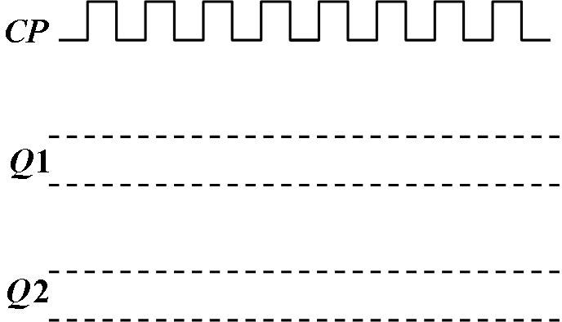

### 实验五 实验报告

**（一）同步十进制计数器**

1. 画出图5-1(a)和5-1(b)中电路输出信号的波形：

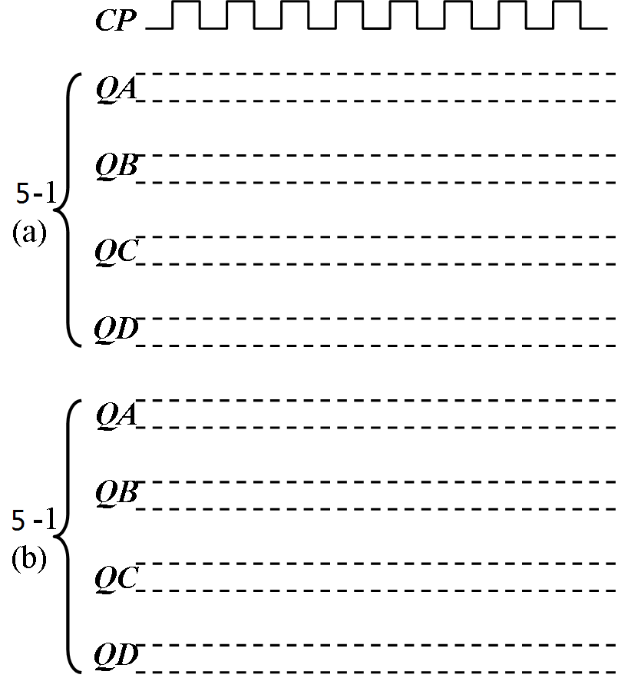

2.

图5-2中计数器的进制是：

它的工作原理是：

**（二）双向移位寄存器**

1.

图5-3中74HC194的作用过程是：

表5-3a：

|  |  |  |  |  |  |  |  |
| --- | --- | --- | --- | --- | --- | --- | --- |
| CP | 输入D | S1 | S0 | QA | QB | QC | QD |
| 0 | 1011 | 1 | 1 |  |  |  |  |
| 1 | 1011 | 1 | 1 |  |  |  |  |

表5-3b：

|  |  |  |  |  |  |  |  |
| --- | --- | --- | --- | --- | --- | --- | --- |
| CP | 输入D | S1 | S0 | QA | QB | QC | QD |
| 0 | 0 | 0 | 1 |  |  |  |  |
| 1 | 1 | 0 | 1 |  |  |  |  |
| 2 | 0 | 0 | 1 |  |  |  |  |
| 3 | 1 | 0 | 1 |  |  |  |  |
| 4 | 1 | 0 | 1 |  |  |  |  |

表5-3c：

|  |  |  |  |  |  |  |  |
| --- | --- | --- | --- | --- | --- | --- | --- |
| CP | 输入D | S1 | S0 | QA | QB | QC | QD |
| 0 | 0 | 1 | 0 |  |  |  |  |
| 1 | 1 | 1 | 0 |  |  |  |  |
| 2 | 0 | 1 | 0 |  |  |  |  |
| 3 | 1 | 1 | 0 |  |  |  |  |
| 4 | 1 | 1 | 0 |  |  |  |  |

2. 图5-4中的计数器所完成的功能：

状态转移图：

### 实验六 实验报告

**（一）**

**1. 24进制同步计数器电路图：**

**2. 31进制同步计数器电路图：**

**（二）模13扭环计数器电路图：**